AWS Task-4
Task Description:
Launch an EC2 instance (Linux and Windows) along with a web server. Then, create an EBS volume of 5 GB, attach it to an EC2 machine (Linux and Windows), and take a snapshot. Finally, create an EBS volume using the taken snapshot.
Techstacks needs to be used :
- AWS EBS
- AWS EC2

Windows EC2 Instance Created:
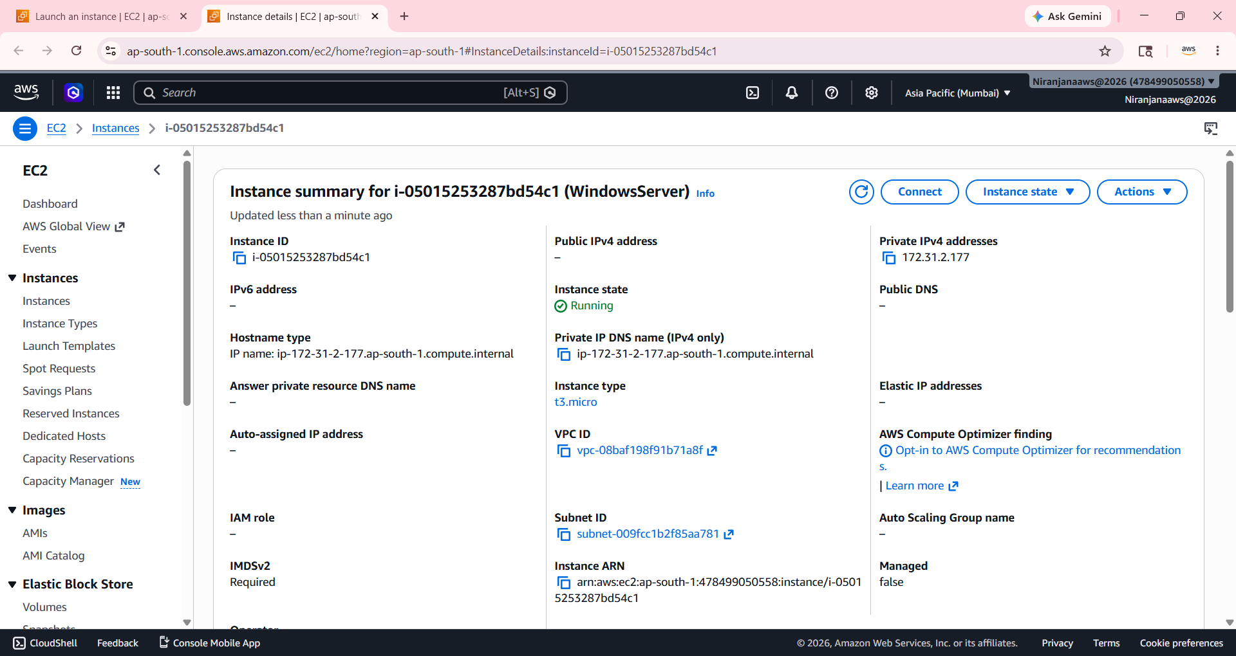

Linux EC2 Instance Created:

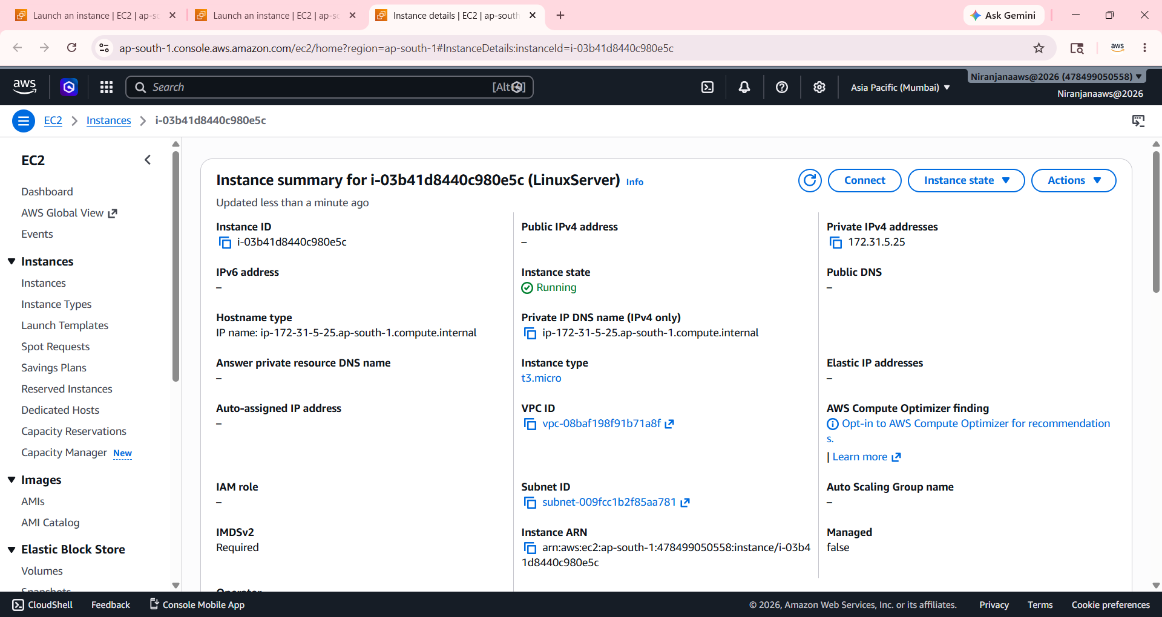

Created EBS Volume:
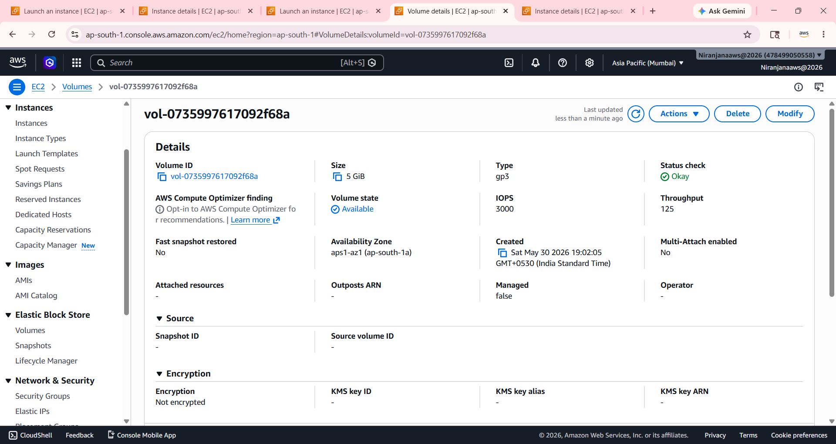

Attached Volume on Windows Server:
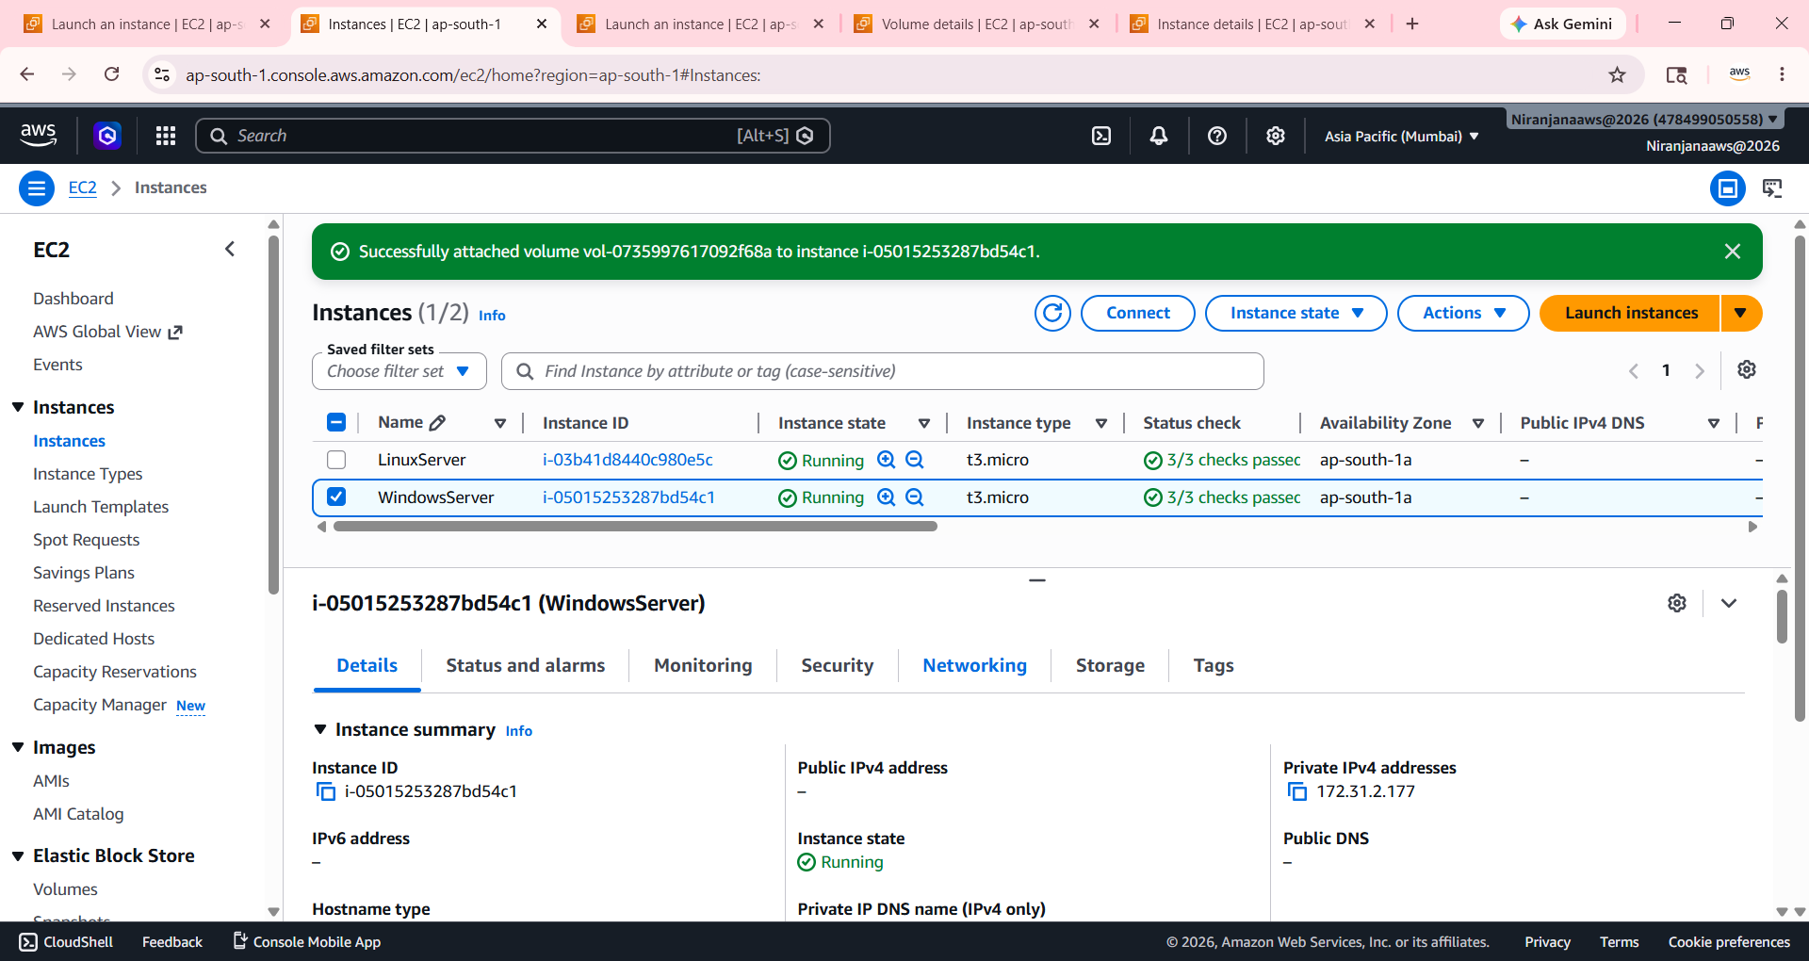

Detached Volume :

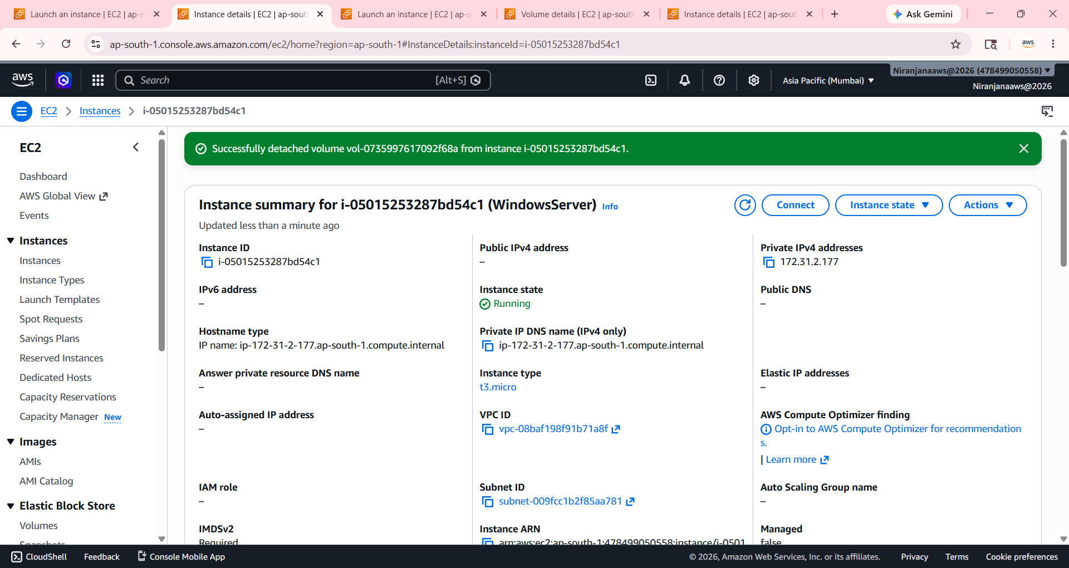

Attaching Volume on Linux Server:

